EXERCISE 1 - Estimation of project cost and control activity using open-source tools

AIM:
To estimate the project cost, allocate resources, monitor project activities, and control project progress using an open-source project management tool (such as ProjectLibre or OpenProject).

ALGORITHM:
• Define the project activities.
• Estimate the duration of each activity.
• Assign resources and their costs.
• Create the project schedule.
• Calculate the estimated project cost.
• Monitor task progress during execution.
• Compare planned cost with actual cost.
• Identify cost or schedule deviations.
• Update the project plan to control project performance.

PROCEDURE :
• Install and open an open-source project management tool (e.g., ProjectLibre).
• Create a new project and enter project details.
• Add all project tasks with their estimated durations.
• Define task dependencies.
• Create resources (employees, equipment, etc.) and assign hourly or daily costs.
• Assign resources to the respective tasks.
• Generate the Gantt Chart and Resource Sheet.
• View the project cost estimation generated by the software.
• Update task completion percentages to monitor progress.
• Compare planned cost and actual cost using project reports.
• Identify delays or cost overruns and revise the schedule if required.
• Save the project and generate the final reports.

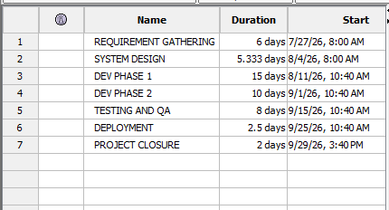
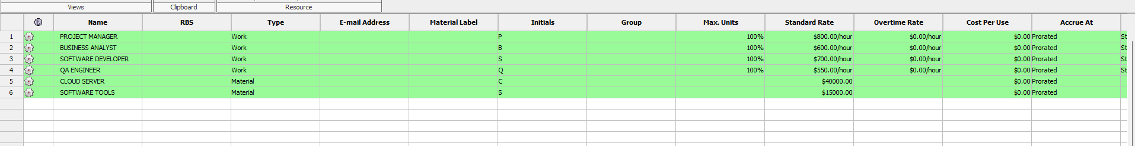

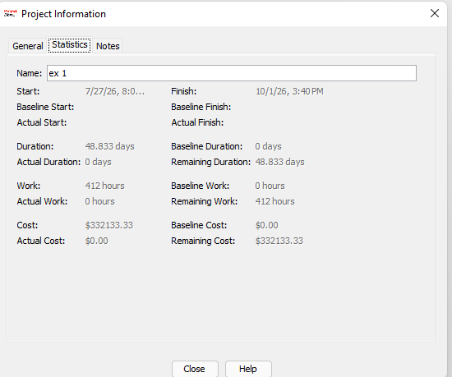
The software successfully generated the project schedule and estimated the total project duration as 48.833 days, total work as 412 hours, and the estimated project cost as $332,133.33

RESULT:
The project cost was successfully estimated, and project activities were monitored and controlled using an open-source project management tool. The software provided task scheduling, resource allocation, cost estimation, and progress tracking, enabling effective project planning and control.

